Title of the paper

Track: Community (write the chosen Track)

Author’s name and surname[1] (style: Authors)

Affiliation, Institution, Address, e-mail (style: Author data)

Author’s name and surname

Affiliation, Institution, Address, e-mail

Author’s name and surname

Affiliation, Institution, Address, e-mail

Abstract (style: Abstract heading)

Abstract text, Abstract text, Abstract text, Abstract text, Abstract text, Abstract text, Abstract text, Abstract text, Abstract text, Abstract text, Abstract text, Abstract text, Abstract text, Abstract text, Abstract text, Abstract text, Abstract text, Abstract text, Abstract text, Abstract text, Abstract text, Abstract text, Abstract text, Abstract text, Abstract text, Abstract text... (style: Abstract text)

(max. 300-500 words)

**Keywords**: Keyword 1, Keyword 2, Keyword 3, etc. (max 5 words)

Introduction (style: Title of the paragraph)

The aim of the Urban Planning for Social Resilience in Urban Neighborhoods. Transformative Change through civic engagement (UPRUN) research project is to provide future planners and other built environment professionals with a more sophisticated understanding of neighbourhood resilience. For this, UPRUN will identify strategies to strengthen social participation, resilience and sustainability in urban communities and neighbourhoods. (style: Paragraph text)

Title of the paragraph (style: Title of the paragraph)

In many European cities, we can observe that civil society actors increasingly appropriate public spaces and contribute to the co-production of neighborhoods. As consequence, numerous ‘experimental spaces’ exist in cities, where ‘city makers’ develop social innovations and test new structures or new practices. Social innovations that emerge from organized citizenship have the potential to make a valuable contribution in addressing social and cultural issues in the neighborhoods of European cities, and can contribute to the development of resilient communities. These transformative processes have the potential to confront fragmentation and exclusion in neighbourhoods, and are thought to provide the groundwork for an educational mission of architects, urban planners and designers and other built environment professionals. More attention is needed to understand the dynamics of civic engagement and community resilience in a comprehensive way and to gain knowledge on how to strengthen neighborhood resilience in an environment characterized by change, uncertainty, and unpredictability. (style: Paragraph text)

Title of the sub-paragraph (style: Title of the sub-paragraph)

The aim of UPRUN is thus to provide future planners and other built environment professionals with a more sophisticated understanding of neighbourhood resilience. For this, UPRUN will identify strategies to strengthen social participation, resilience and sustainability in urban communities and neighbourhoods. The findings are used to develop hybrid teaching modules enabling students to make urban neighbourhoods more resilient via planning, collective action, innovation and learning. (style: Paragraph text)

Table 1: Table title (style: Caption, Table title)

|  |  |  |
| --- | --- | --- |
|  | Title of the column | Title of the column |
| Title of the row | text/value | text/value |
| Title of the row | text/value | text/value |
| Title of the row | text/value | text/value |

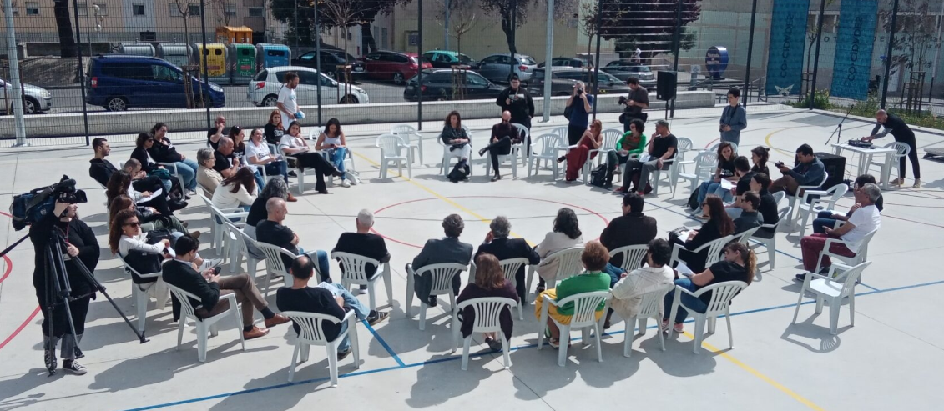

Figure 1: Figure title (style: Figure title) Figure size 300dpi

Conclusions (style: Title of the paragraph)

UPRUN will establish a multi-lingual digital knowledge and learning platform providing open-access to a database with educational material and relevant case studies on ‘Planning for Social Resilience in Urban Neighbourhoods’. This concerns the compilation of a self-contained course, including e-learning components using digital participatory and learning tools. A handbook will explain the intentions and use of the teaching module. The module is tested and evaluated in real courses.

References (style: Title of the paragraph)

**The list of references should be correctly formatted in APA style.**

**Additional note:**

The paper should be named as follows: UPRUN paper_name_surname.docx

Authors are asked to respect and use established styles and have between **4000- 5000 words** **including references** for the full paper.

1. Corresponding author